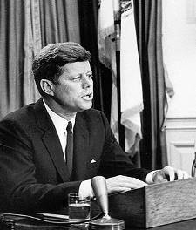
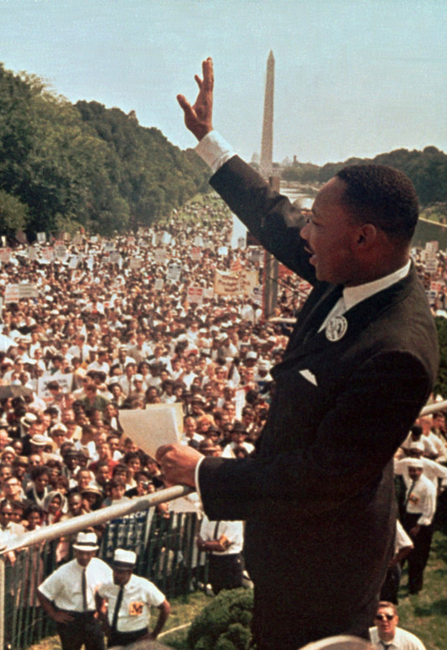
1964 CIVIL RIGHTS ACT
On June 11, 1963, President John F. Kennedy gave a televised speech talking about the importance of civil rights for ALL Americans. He then asked Congress to create an Act (law) that protected the freedoms of African Americans by outlawing discrimination and segregation. The bill was passed in both the House of Representatives and the Senate, and signed into law by President Lyndon B. Johnson (who succeeded President Kennedy after he was assassinated). It should be noted that many Southern US Congressmen did not support the Civil Rights Act. Only 8 out of 127 Southern politicians voted to pass the Civil Rights Act, compared to 355 out of 394 of non-Southern politicians, and Southern attempts to preserve white supremacy failed.

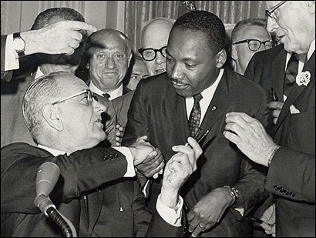

SS8H11c Discuss the impact of Andrew Young on Georgia.

CIVIL RIGHTS MOVEMENT IN THE 1970s

1900 1910 1920 1930 1940 1950 1960 1970 1980 1990 2000

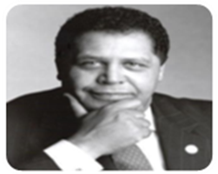
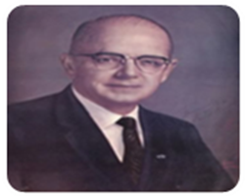

1967
LESTER MADDOX
A strict segregationist who became governor of Georgia in 1967. He once shutdown his own restaurant business “Pickrick Cafeteria” instead of desegregating. However, once he became governor of Georgia he promoted and hired more African-Americans in government jobs than previous governors. He also integrated the Georgia State Highway Patrol and GBI. He also appointed the first African American to head a state department.

1974
MAYNARD JACKSON
In 1974, Maynard Jackson became the 1st African-American mayor of a major southern city (Atlanta). Jackson played a important role in expanding and modernizing Atlanta’s airport, which has become the busiest airport in the world and employs thousands of workers in the Atlanta area, now named Atlanta Hartsfield-Jackson International Airport to honor his contributions. Played a role in bringing the 1996 Olympics to Atlanta.

1977
ANDREW YOUNG
Former Civil Rights activist during the Civil Rights movement who was friends with Dr. King. Andrew Young also became the first African-American US Representative from Georgia since the Reconstruction Era. President Jimmy Carter appointed Young as the first African-American UN Ambassador. Like Maynard Jackson he also became mayor of Atlanta and later helped bring the Olympics to Georgia.

SS8H11a Describe major developments in civil rights and Georgia’s role during the 1940s and 1950s; include the roles of Herman Talmadge, Benjamin Mays, the 1946 governor’s race and the end of the white primary, Brown v. Board of Education, Martin Luther King, Jr., and the 1956 state flag.

CIVIL RIGHTS MOVEMENT IN THE 1940s

1900 1910 1920 1930 1940 1950 1960 1970 1980 1990 2000
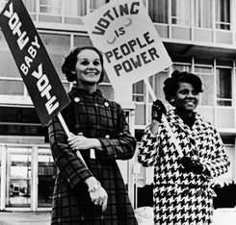
1946: END OF WHITE PRIMARIES
As governor of Georgia, Ellis Arnall enforced the court decision to stop the unfair practice of White Primaries, which had disenfranchised black voters. African-Americans could now vote during the primary election in July for either black candidates or non-racist white candidates. Racist white candidates no longer automatically advanced to the General Election because there was no opposition in white primaries. However, the county unit system still gave rural counties a huge advantage, which is where a majority of the racist voters lived in Georgia.

HERMAN TALMADGE
Just like his dad, Herman Talmadge was a racist governor who supported segregation. He became governor during the “3 governors controversy” when Eugene Talmadge won the 1946 Governor’s Race in November, but died before taking office. Herman received write-in votes because voters knew his dad was ill. The Georgia Supreme Court ruled that a special election must be held between Herman Talmadge and Melvin Thompson. Talmadge won because of the county unit system.
.

Ellis Arnall?
Wanted to remain governor until controversy was settled

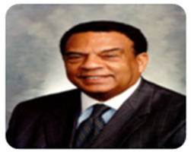
1946 GOVERNOR’S RACE
“the 3 governors controversy”
Who will replace
Eugene Talmadge?
.

Herman Talmadge?
Received enough “write-in” votes on the ballot

Melvin Thompson?
Was elected Lieutenant Governor of Georgia

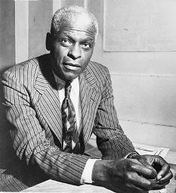
BENJAMIN MAYS
As president of Morehouse College in Atlanta, Dr. Mays was a civil rights activist and mentor to Martin Luther King, Jr. In 1936, Dr. Mays traveled to India and visited with Mohandis Gandhi and learned Gandhi’s philosophy of non-violent protests and boycotts. Martin Luther King, Jr. would learn this from his mentor Benjamin Mays and it would be the strategy during the Civil Rights movement to end segregation and gain racial equality. Dr. Mays gave the Benediction at the March on Washington, as well as Dr. King’s eulogy.

CIVIL RIGHTS MOVEMENT IN THE 1950s

1900 1910 1920 1930 1940 1950 1960 1970 1980 1990 2000
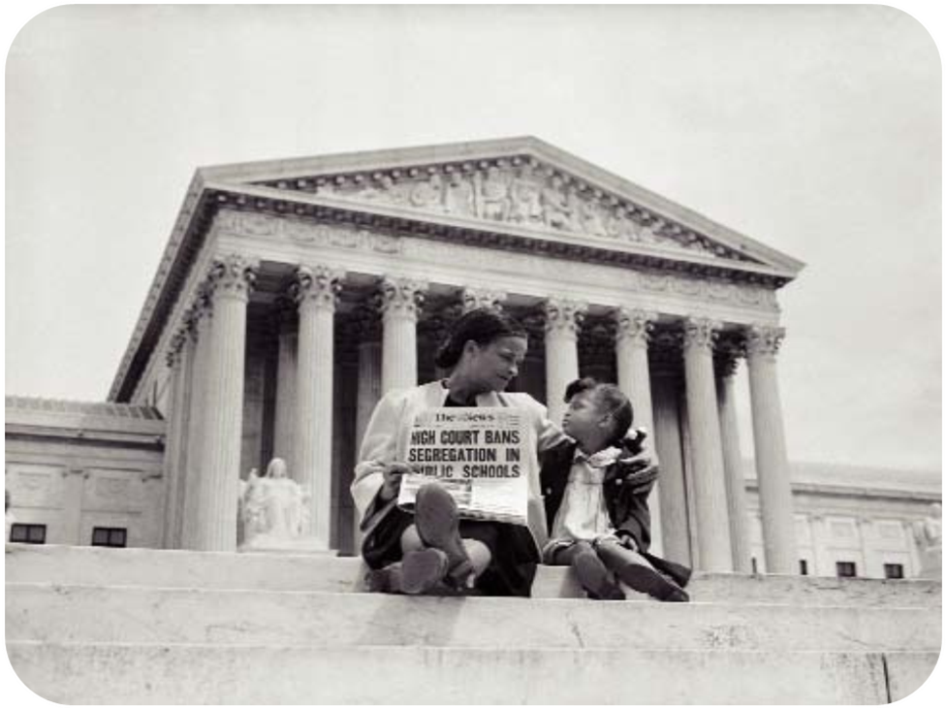
1954 BROWN vs BOARD OF EDUCATION
This landmark US Supreme Court case overturned the 1896 Plessy v. Ferguson case which had made the segregation of races legal as long as facilities were equal. In 1954, all 9 of the Supreme Court justices ruled that segregation did not provide equal facilities or opportunities for African-Americans. This federal ruling meant that states would eventually have to outlaw segregation in public schools and begin integrating their school systems. Former Confederate States used a “massive resistance” policy as a way to avoid desegregating their schools. This only promoted racism in the Deep South.

END OF PUBLIC SCHOOL SEGREGATION

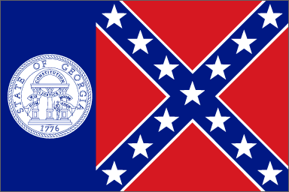
1956 GEORGIA STATE FLAG
Many white Georgians were angered by the federal Supreme Court decision to outlaw segregation of public schools. As a symbol of protest, the Georgia General Assembly approved a new state flag that contained the old Confederate battle flag. This flag was a symbol of states’ rights that was once used to preserve the practice of slavery, and now was used to preserve segregation.

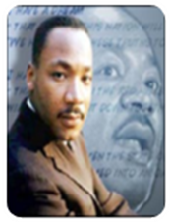
Dr. MARTIN LUTHER KING, Jr.
Recognized as the most influential leader during the Civil Rights movement. Martin Luther King, Jr. was educated at Morehouse College and Boston University. While at Morehouse College in Atlanta, Martin Luther King, Jr. learned about non-violent protest and civil disobedience from his mentor Dr. Benjamin Mays. As pastor of a Baptist church in Montgomery, Alabama, Dr. King began organizing the Montgomery Bus Boycott after Rosa Parks was arrested for violating an unfair segregation law on a public city bus. Dr. King also founded the SCLC (Southern Christian Leadership Committee) to help build the Civil Rights movement. In 1961, Dr. King along with the NAACP and SNCC organized the Albany Movement to help desegregate the south Georgia city, only to be arrested by police. On August 28th, 1963, Dr. King gave his most empowering “I have a Dream” speech during the March on Washington. In 1968, Dr. King was assassinated, but his legacy will be remembered forever by many.
.
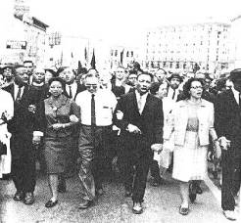

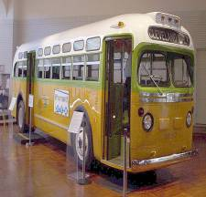
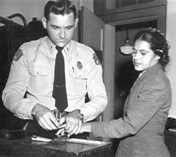

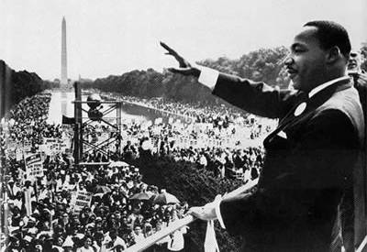
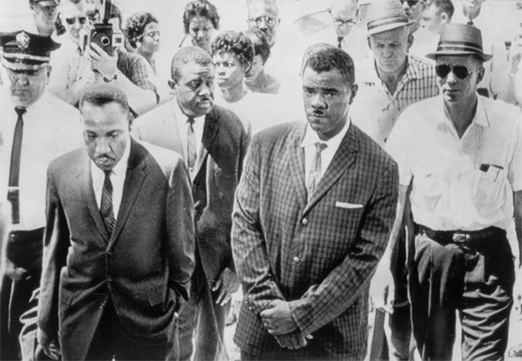
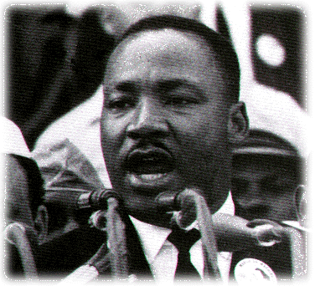

SS8H11b Analyze the role Georgia and prominent Georgians played in the Civil Rights Movement of the 1960s and 1970s; include such events as the founding of the Student Non-Violent Coordinating Committee (SNCC), Sibley Commission, admission of Hamilton Holmes and Charlayne Hunter to the University of Georgia, Albany Movement, March on Washington, Civil Rights Act, the election of Maynard Jackson as mayor of Atlanta, and the role of Lester Maddox.

CIVIL RIGHTS MOVEMENT IN THE 1960s

1900 1910 1920 1930 1940 1950 1960 1970 1980 1990 2000
1960 SIBLEY COMMISSION Desegregate means to end the practice of segregation. Many school districts in Georgia threatened to close their schools if they were forced to desegregate. The Sibley Commission was a plan by the Georgia government to decide how Georgia’s counties should integrate their schools. Eventually, the federal government threatened to cut off funding to Georgia schools because the state was very slow in outlawing segregation.

1960 SNCC (Student Non-Violent Coordinating Committee)
Throughout the South, groups of black and white students were inspired by Dr. King’s methods of non-violence and civil disobedience in order to challenge unfair segregation laws. Young students began to boycott segregated businesses, using sit-ins to cause businesses to lose money and eventually desegregate. SNCC also used Freedom Rides as a way to protest unfair segregation on buses.

1961 UGA DESEGREGATION It wasn’t until 1961 that African-Americans were allowed to attend the University of Georgia. Hamilton Holmes and Charlayne Hunter were the first black students integrated in the all-white college. Both students were harassed, taunted, and threatened as they first began attending classes. By 1963, both had earned their degrees and went on to have successful careers. Today, the Holmes-Hunter Academic Building is named in their honor.

1961 ALBANY MOVEMENT SNCC, NAACP, and Dr. King helped to organize a large movement to end segregation in the south Georgia city of Albany. In addition to marches and boycotts, the protestors also helped African-Americans register to vote. Their efforts to desegregate the city stalled when the Albany police arrested many of the protestors, including Dr. King. Overcrowding jails caused the police to put activists in neighboring county jails.

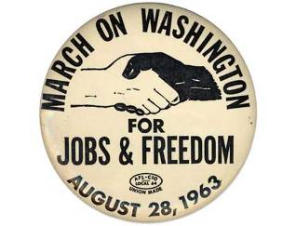
1963 MARCH ON WASHINGTON
One hundred years after Abraham Lincoln signed the Emancipation Proclamation, over 250,000 citizens marched to the Lincoln Memorial in Washington D.C. in order to gain jobs and freedom for African Americans. Many activists spoke to the large crowd, including Dr. Martin Luther King, Jr. The highlight of the March on Washington wasDr. King’s “I Have a Dream” speech, which reminded America of the struggles of African-Americans in society (especially in the South), and the hope that racism and discrimination would no longer be part of the culture of America. The march was so effective that Congress signed the Civil Rights Act and the Voting Rights Act.
Dr. King would earn the Nobel Peace Prize and the March on Washington was a major turning point of the Civil Rights movement.

